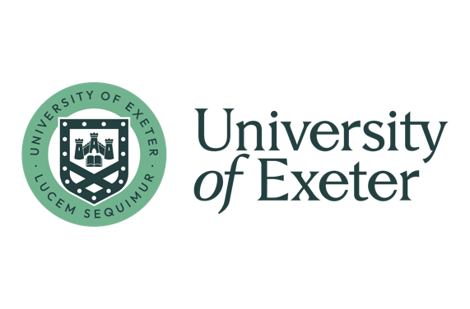

Evening language programme 2025/26

Course title: Italian Post-Beginner Part I (A2.1) - Online

Course descriptor/objectives
The aim of the course is to help the learner to develop basic speaking, writing, listening and reading skills, extend vocabulary and consolidate grammar for communication purposes. Therefore, by the end of the course (Part I & II) participants will be able to:
- Understand sentences and frequently used expressions related to areas of most immediate relevance (e.g. very basic personal and family information, shopping, local geography, employment).
- Can communicate in simple and routing tasks requiring a simple and direct exchange of information on familar and routine matters.
- Can describe in simple terms aspects of their background, immediate environment and matters in areas of immediate need.

Participants will develop basic reading, listening, speaking and writing skills through a series of task-oriented sessions, and will be provided with informal formative feedback during lessons. The completion level of the course is broadly equivalent to the A2.1 level of the Common European Framework.

In seminars, participants will engage in practical exercises and group interaction in order to develop relevant language learning strategies. The tutor will facilitate this process, provide useful tools and encourage participants to become independent learners and confident users of the language.
Language-specific information:
Italian is spoken by around 85 million people worldwide, with approximately 67 million native speakers in Europe, making it one of the most widely spoken national languages in the EU. It is an official language in Italy, Switzerland, San Marino, and the Vatican, and there are significant Italian-speaking communities in many other countries, including the United States. The British Council has also identified Italian as one of the ten most important languages for the UK in its Languages for the Future report.
Italian is strongly associated with rich cultural traditions in art, music, and cuisine, and many Italian terms have become part of international vocabularies through these fields.
Derived from the Latin of the Roman Empire, Italian retains many linguistic features that reflect this heritage. Historically, varieties of Italian used by medieval trading powers also served as an important lingua franca across the Mediterranean, leaving a lasting influence and contributing loanwords that persist today.

Prerequisite:
This non-credit bearing weekly course is intended for Italian language learners who have previously completed a Beginner A1.2 course in the ELP (have completed A1 level) or equivalent. You have already covered the ‘passato prossimo’ tense.
Technical requirements:
-PC, laptop or tablet with camera and microphone
-Stable internet connection
Delivery will be via Zoom
Once the course is confirmed, your teacher will send you an invitation for the first online session. You can expect to receive this invitation one day before the first session.

Coursebook and/or learning resources:
Continuation (A2.1 part) of Viaggiamo in Italia 1 (Alma Edizioni), ISBN 9788861827264
Please do not purchase the coursebook until the course has been confirmed!

